Free PD!
Generously funded by
The National Science Foundation and
STEM Next

Coaching and Professional Development on
STEM Facilitation Skills

FREE innovative and reflective PD provided by
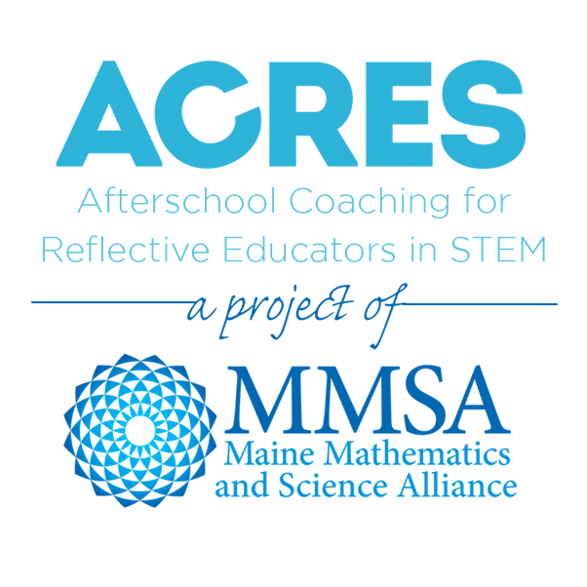
A $250 value offered at no cost to participants
Register for an upcoming cohort for afterschool educators:
Registration Deadline: [one week prior to the start of cohort]
[Insert information on how they will register]

Session 1: Virtual Workshop
Day, date, and time
How can we use purposeful questioning to drive STEM learning?

Session 2: Virtual Coaching Session
Day, date, and time
Receive coach and peer feedback on a video recording of your practice with youth

Session 3: Virtual Coaching Session
Day, date, and time
Receive coach and peer feedback on a second video recording of practice with youth

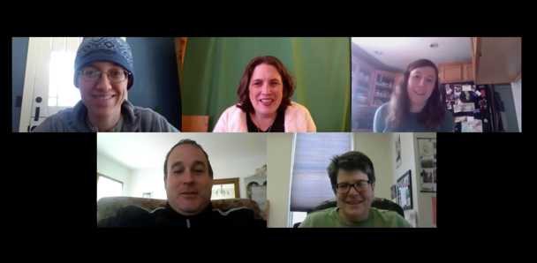
Questions? Put Coach’s contact here information here

Want to get involved?

- Registration deadline day and year
- Thanks to the generosity of the Noyce Foundation and National Science Foundation, there is no cost for participants.
- On day and date the group will gather for a virtual workshop on Asking Purposeful Questions.
- You will then record yourself working with youth- we are not looking for perfect video nor perfect practice.
- On day and date, you will participate in a virtual coaching session with peers and a coach to discuss your videos and receive feedback. After this session, you’ll return to your program and practice given the feedback you received.
- On day and date you will participate in a second virtual coaching session around asking purposeful questions with peers and a coach.

We’re looking for people who:

- Have consistent interactions with youth
- Are comfortable with recording and uploading videos to secure cloud sharing sites
- Are comfortable with video conferencing or willing to learn
- Have access to high speed internet, a computer, and to a cell phone, tablet or camera with video capability
- Have a willingness to learn and reflect on practice in a cohort of peers from across the United States

ACRES Project

What are participation benefits?

- Exposure to current research surrounding STEM education for youth and access to new ways of interacting with youth and other ways to teach STEM skills
- Develop mastery in using technology for learning new skills
- Build relationships with peers who are doing similar work
- Experience personalized professional development to deepen your skills
- Earn contact hours and a certificate of participation

What happens during the PD cycle?

- Participate in three virtual sessions over Zoom video conferencing- these are interactive and engaging.
- Learn about and practice the art of Asking Purposeful Questions during STEM facilitation.
- After the workshop, practice the skill and record yourself working with youth– you can just use a cell phone, camera, or tablet. Recordings need to be only 3 minutes long.
- Join peers to receive compliments, feedback, and coaching on your teaching of the targeted skill

